**EXPERIMENT NO: 9**

**To design a network using three routers and dynamic routing**

**Aim**

To design a network using three routers and configuring their routing tables for dynamic routing.

**Objectives**

1. Studying and implementing dynamic routing.
2. Connecting different networks using routers, configuring the interfaces and routing tables of the routers to perform dynamic routing.

**Procedure**

**Design following network scenario:**

1. Start packet tracer and design the network as given in Figure 1.
2. Configure the router and end devices as described in section below.
3. Test the configuration by sending simple PDUs.

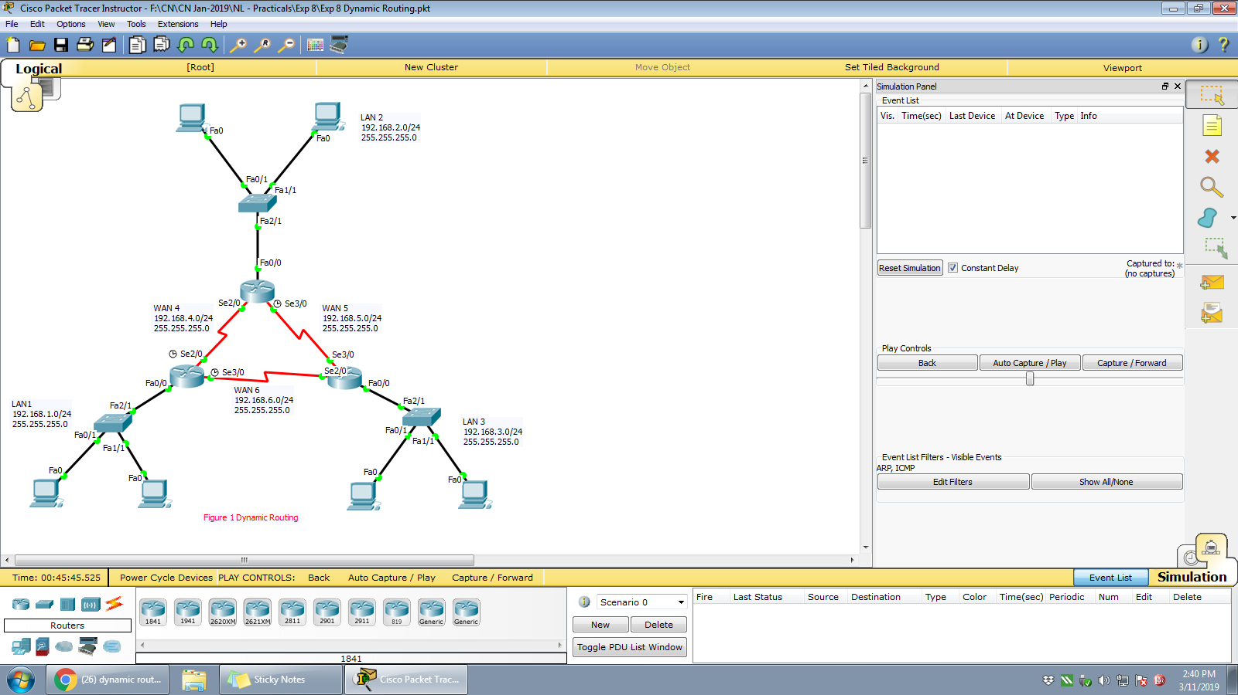

**Details of Router Configuration:**

1. Reboot Router by powering it off and on under the physical tab.
2. Router performs the Power ON Self-Test (POST).
3. Click on ‘Config’ tab and then choose one of the interfaces for configuration. Provide appropriate IP address and subnet mask.
4. Proceed similarly for all other interfaces in use.
5. To update the routing table of Router follow these steps,
   1. Identify magnifying glass icon available at the vertical right pane of the packet tracer. Click the magnifying glass on to Router and select the routing table from the drop down list. A routing table for Router will be displayed having 2 entries typed as C (connected) with next hop field blank.
   2. The routing table is to be updated with the next hop entry, so that the Simple PDU could be send on to the other network. Provide addresses of the networks you want the router should be able to connect to. This can be done from routing ‘RIP’ option in ‘Config’ tab.
6. Configure all the end devices by providing them IP address, subnet mask and the default gateway address.
7. Test your network by sending simple PDU’s or pinging the computers from one network to other network.
8. Specify your network’s router configuration details in table given below.

| **Sr. No.** | **Network Device** | **Configuration (IP address, subnet mask, default gateway addr)** |
| --- | --- | --- |
| 1 | Generic Router 0 | Interface:FASTETHERNET0/0  IP address:192.168.2.1  Subnet address:255.255.255.0 |
| Interface: SERIAL2/0  IP address:192.168.4.1  Subnet address:255.255.255.0 |
| Interface: SERIAL3/0  IP address:192.168.5.1  Subnet address:255.255.255.0 |
| Dynamic Routing Table  Network Addresses:192.168.2.0  192.168.4.0,, 192.168.5.0 |
| 2 | Generic Router 1 | Interface: FASTETHERNET0/0  IP address:192.168.3.1  Subnet address:255.255.255.0 |
| Interface: SERIAL2/0  IP address:192.168.5.2  Subnet address:255.255.255.0 |
| Interface: SERIAL3/0  IP address:192.168.6.2  Subnet address:255.255.255.0 |
| Dynamic Routing Table  Network Addresses:192.168.3.0  192.168.5.0,,,,192.168.6.0 |
| 3 | Generic Router 2 | Interface: FASTETHERNET0/0  IP address:192.168.1.1  Subnet address:255.255.255.0 |
| Interface: SERIAL2/0  IP address:192.168.4.2  Subnet address:255.255.255.0 |
| Interface: SERIAL3/0  IP address:192.168.6.1  Subnet address:255.255.255.0 |
| Dynamic Routing Table  Network Addresses:192.168.1.0  192.168.4.0  192.168.6.0 |

Take screenshots for the network scenario showing successful pakcet transmission from one network to other and attach as the output. Explain the screenshots in detail.

**Conclusion:**

In this experiment the routers interfaces and routing tables are configured to perform dynamic routing and checked that simple PDU’s are transmitted from one network to another through routers. Thus we learned to design a simple network with routers using dynamic routing.

**Post Experiment Exercise:**

Test the network for its dynamic routing by disabling one router to router link. Take screenshots and show the path chosen by the network in case of disabled link. Explain the screenshots in detail.

LAB-EXERCISE

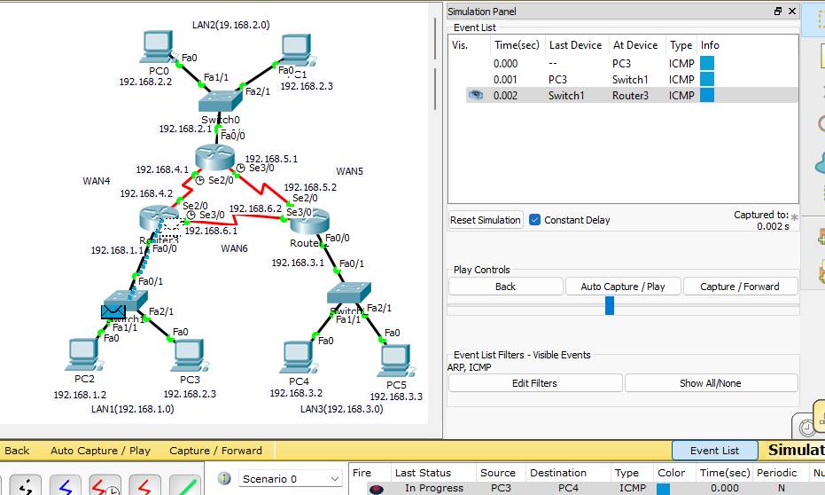

*A PC3 on LAN1 generates a packet with destination IP address that belongs to PC4 on LAN3.So the source device forwards the packet to its gateway.The router3 on LAN1 receives the packet from PC3.Router checks its routing table to determine the best path to reach the destination IP address.As the destination IP address belongs different network,the router selects the next hop towards the WAN based on dynamic routing information it has learned i.e thru WAN6.*

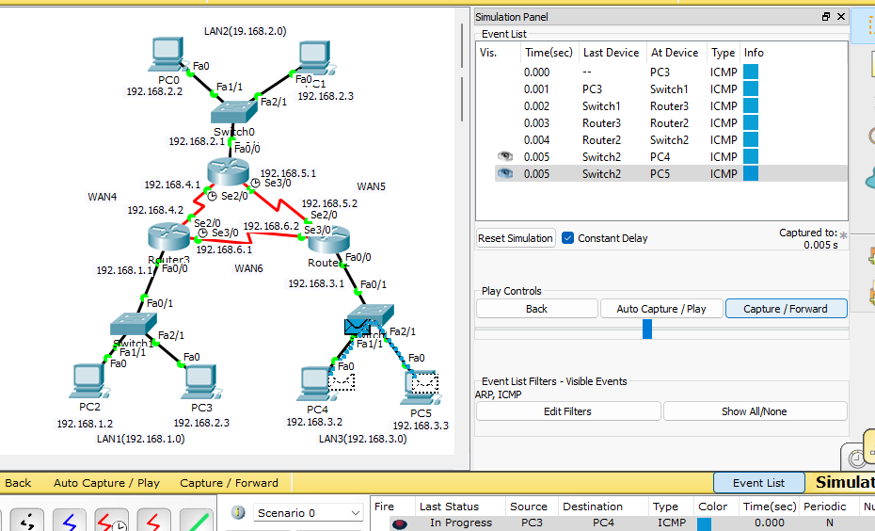

*The router2 receives the packet from WAN6.Router2 examines the destination IP address in the packet and checks its routing table.The router2 encapsulates the packet in a new frame with LAN3 interfaces’s MAC address as the destination MAC address.And the router forwards the packet onto LAN3.*

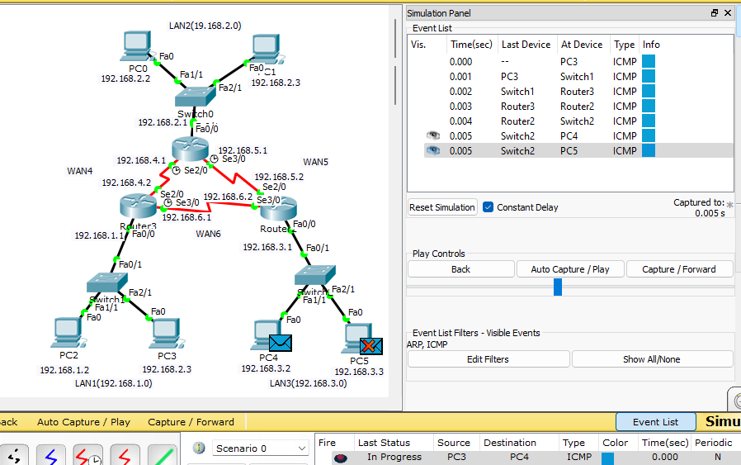

*The packet arrives at LAN3 ,where it is received by the destination device PC4 and is rejected by the other devices on the LAN i.e PC5.The recipient device,PC4 receives the packet and processes the data contained within it..If necessary the recipient device may generate a response.*

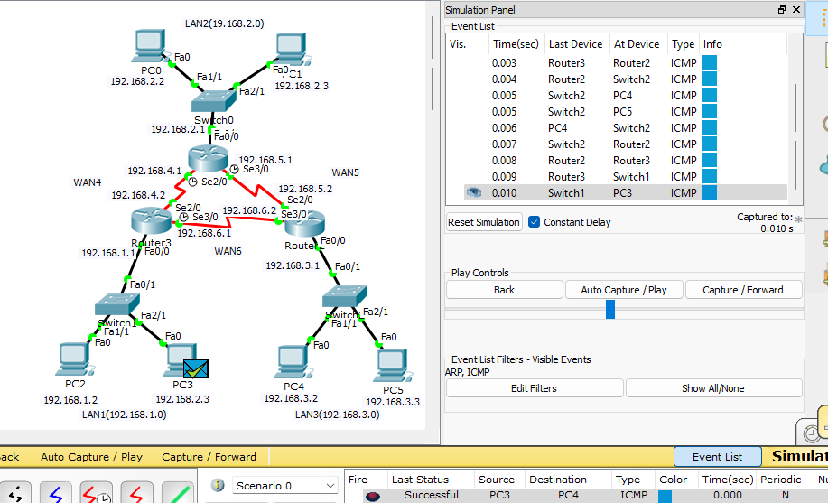

*The generated response hence follows a similar process of routing and transmission back to source device PC3 .Thus, the PDU is gives a successful output on stimulation panel.*

POST_EXPERIMENT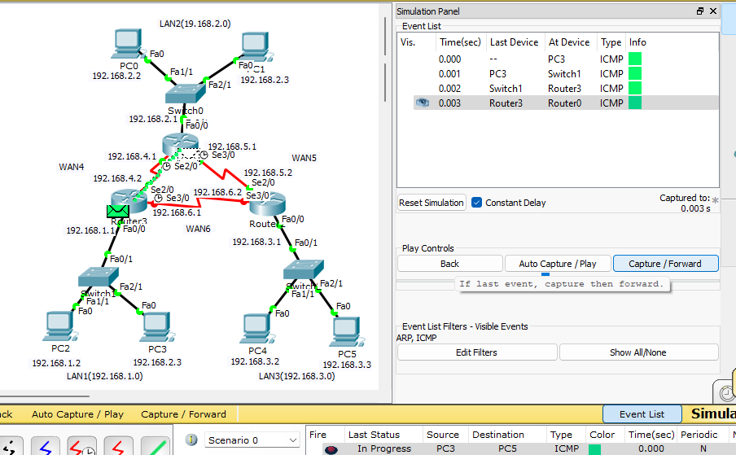

*Now in this scenario we have turned off WAN6 transmission cable and hence we are checking if still successful packet transmission happens or not.*

*PC3 on LAN1 generates a packet with destination IP address that belongs to PC5 on LAN3.So the source device forwards the packet to its gateway.The router3 on LAN1 receives the packet from PC3.Router checks its routing table to determine the best path to reach the destination IP address which is WAN6 but in this scenario its off.*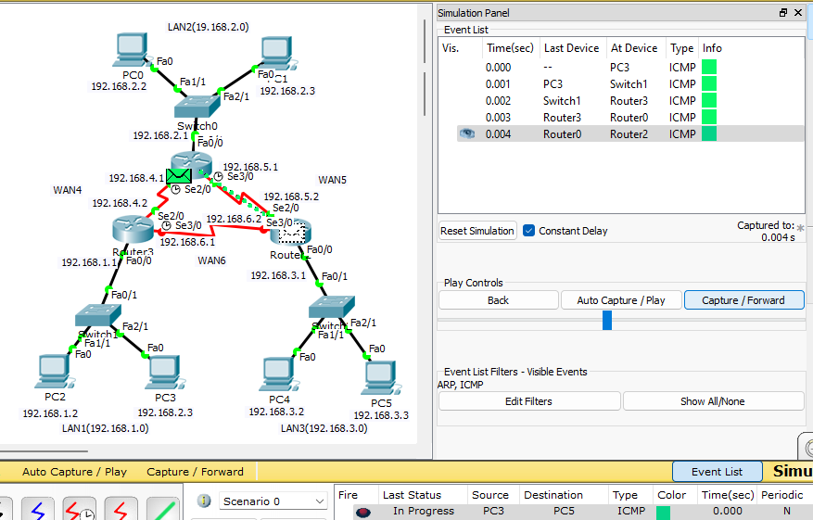

*So router3 opts for an optional path to transmit the packet to LAN3 which is through WAN4 and then to WAN5.Router0 receives the packet from router3 it examines the destination IP address in the packet and checks its routing table.Based on dynamic routing information forwards it to next hop i.e router2 through WAN5.*

.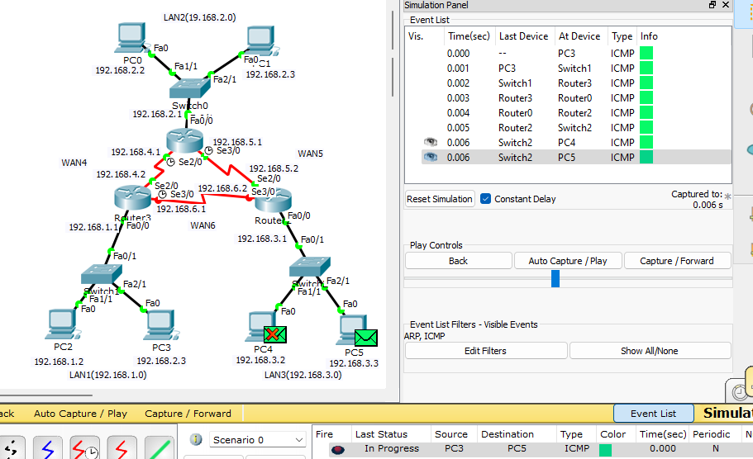

*The packet arrives at LAN3 ,where it is received by the destination device PC5 and is rejected by the other devices on the LAN i.e PC4.The recipient device,PC5 receives the packet and processes the data contained within it..If necessary the recipient device may generate a response.*

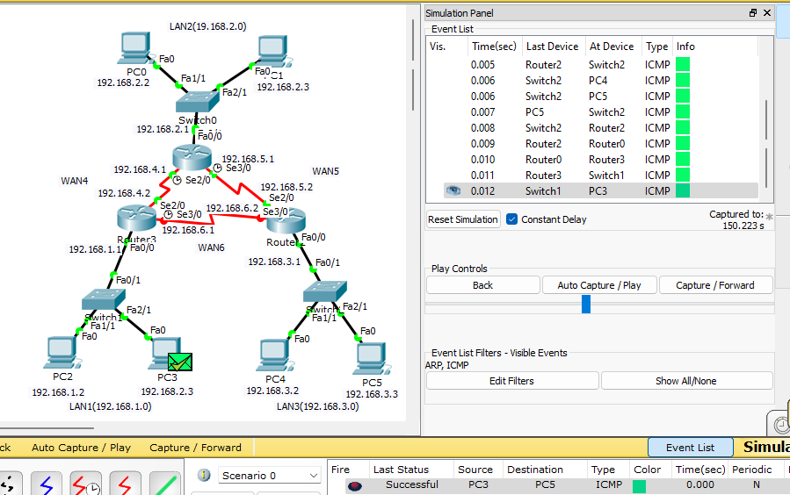

*The generated response hence follows a similar process of routing and transmission back to source device PC3 .Thus, the PDU is gives a successful output on stimulation panel.*